SpendWise: A Simple Backend Learning Project
Ideation Phase
Brainstorm & Idea Prioritization

Date | 7 February 2026
Team ID | SWTID-2026-9031
Project Name | SpendWise
Maximum Marks | 4 Marks

Data Flow Diagram (DFD)
A Data Flow Diagram (DFD) shows how data moves through the SpendWise backend system. It explains how users interact with the API, how requests are processed, and how data is stored in the database.
The diagram helps developers understand:
- How user requests enter the system
- How authentication is verified
- How transactions are created, updated, or deleted
- How data is stored and retrieved from the database
In SpendWise, the main components include:
- User (API Client) – Sends requests such as register, login, and manage transactions
- SpendWise API Server – Handles authentication and processes requests
- Authentication Service (JWT) – Verifies user identity and protects routes
- Database (MongoDB) – Stores user accounts and transaction records
The system processes incoming API requests and returns responses such as success messages, tokens, or stored transaction data. This structured flow improves security and ensures users can only access their own information.

SpendWise – Data Flow Diagram
Level 0 DFD (System Overview)
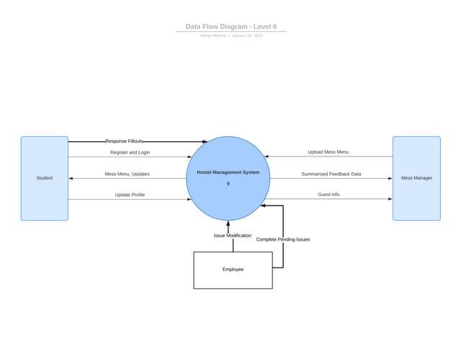

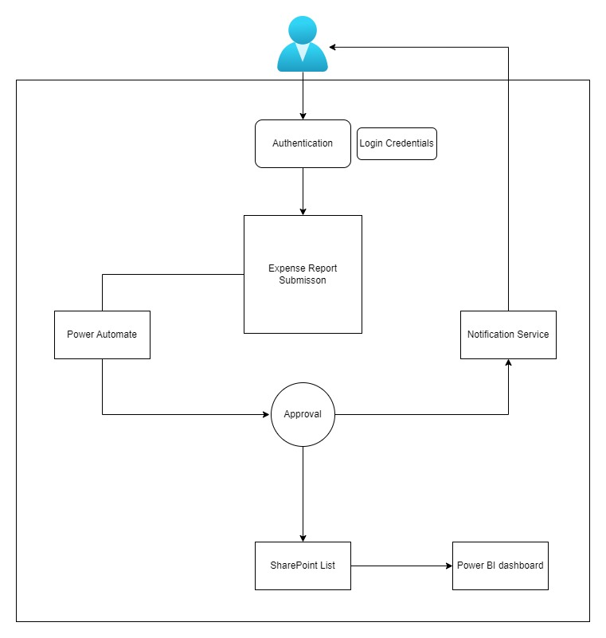
Explanation
- The User sends a request to the SpendWise API.
- The system processes actions like registration, login, or transaction management.
- Authentication is handled using JWT tokens.
- Data is stored or retrieved from the MongoDB database.
- The API sends a response back to the user.

Level 1 DFD (Detailed Flow)
Example processes inside the system:
- User Registration
  - User submits name, email, password
  - System validates data
  - Account is saved in database
- User Login
  - Credentials are verified
  - JWT token is generated
  - Token is returned to user
- Transaction Management
  - Add transaction
  - Update transaction
  - Delete transaction
  - Retrieve user transactions

User Stories
User Type | User Story Number | User Story / Task | Acceptance Criteria | Priority | Release
User (API Client) | US-01 | As a user, I want to create a new account using email and password | Account is successfully created and confirmation message returned | High | Sprint-1
User (API Client) | US-02 | As a user, I want to authenticate using my credentials | System verifies credentials and returns JWT token | High | Sprint-1
User (API Client) | US-03 | As a user, I want secure access to protected routes | Requests without valid JWT token are denied | High | Sprint-2
User (API Client) | US-04 | As a user, I want to add an expense or income record | Transaction is stored in database and response is returned | High | Sprint-2
User (API Client) | US-05 | As a user, I want to view my financial transactions | System returns only transactions related to the user | High | Sprint-2
User (API Client) | US-06 | As a user, I want to modify my transaction details | System updates the selected transaction successfully | Medium | Sprint-3
User (API Client) | US-07 | As a user, I want to remove a transaction record | Transaction is deleted and confirmation message is returned | Medium | Sprint-3
User (API Client) | US-08 | As a user, I want my data to remain private | System prevents access to other users’ data | High | Sprint-3

